Experiment 9

Student Name: Nikhil Kumar UID: 25MCI10036
Branch: MCA (AI/ML) Section/Group: 25MAM-1(A)
Semester: 2-SEM Date of Performance: 07/04/2026
Subject Name: Technical Training - 1 Subject Code: 25CAP-652

- Aim of the Session:

To implement database triggers in PostgreSQL to automatically calculate values and enforce constraints during data insertion operations.

- Software Requirements:
- PostgreSQL
- pgAdmin
- Windows Operating System

- Objectives of the Session:
- Trigger Implementation: To understand how to create and use triggers in PostgreSQL.
- Automation: To automate calculation of total payable amount using triggers.
- Data Integrity: To enforce constraints using trigger conditions.
- Real-time Processing: To execute logic automatically before inserting data.

- Theory:

Triggers are special database objects that automatically execute a function when a specified event (INSERT, UPDATE, DELETE) occurs on a table. In PostgreSQL, triggers are associated with trigger functions written in PL/pgSQL. They help maintain data integrity, enforce business rules, and automate tasks.

- Practical / Experiment Steps:

Step 0: Create table query

Code:

CREATE TABLE employee (

emp_id INT PRIMARY KEY,

emp_name VARCHAR(50),

working_hours INT,

perhour_salary NUMERIC,

total_payable_amount NUMERIC

);

Step 1: Creating trigger function query.

Code:

CREATE OR REPLACE FUNCTION CACULATE_PAYABLE_AMOUNT() RETURNS TRIGGER

AS

$$

BEGIN

NEW.total_payable_amount:=NEW.perhour_salary*New.working_hours;

IF NEW.total_payable_amount>25000 THEN

RAISE EXCEPTION 'INVALID ENTRY BEACUSE PAYABLE AMOUNT CAN NOT BE GREATER THAN 25000';

END IF;

RETURN NEW;

END;

$$ LANGUAGE PLPGSQL;

Step 2: Creating trigger query.

Code:

CREATE OR REPLACE TRIGGER AUTOMATED_PAYABLE_AMOUNT_CALCULATION

BEFORE INSERT

ON employee

FOR EACH ROW

EXECUTE FUNCTION CACULATE_PAYABLE_AMOUNT()

Step 3: Inserting valid data.

Code:

INSERT INTO EMPLOYEE (EMP_ID, EMP_NAME, working_hours, perhour_salary)

VALUES (1, 'AKASH', 10, 1000);

Output:

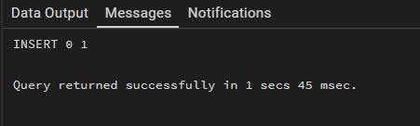

Step 4: Inserting Invalid data (Exception case).

Code:

INSERT INTO EMPLOYEE (EMP_ID, EMP_NAME, working_hours, perhour_salary)

VALUES (2, 'ANKUSH', 8, 100000);

Output:

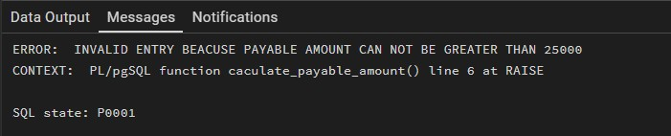

Step 5: Retrieving data query.

Code:

SELECT * FROM EMPLOYEE;

Output:

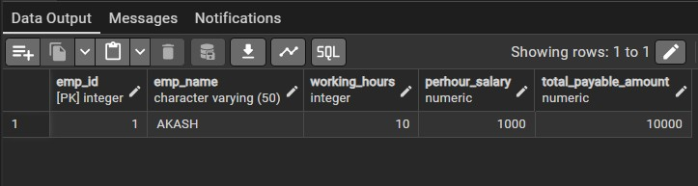

- Learning Outcomes (What I have learned):
- Students will be able to create and use triggers in PostgreSQL.
- Students will understand how to automate calculations using triggers.
- Students will enforce constraints using trigger conditions.
- Students will understand real-time execution of database logic.

